|  |  |  |  |
| --- | --- | --- | --- |
| **Employee Table** | | | |
| Department | EmpiD | EMPname | EMPStatus |
| HR | 1 | A | FTE |
| HR | 2 | B | FTE |
| Sales | 3 | C | FTE |
| IT | 4 | D | Contractor |
| Sales | 5 | E | FTE |
| IT | 6 | F | Contractor |

|  |  |  |
| --- | --- | --- |
| **Worklog Table** | | |
| EMPID | HoursWorked | Financial Year |
| 1 | 200 | 2001 |
| 2 | 300 | 2001 |
| 3 | 500 | 2001 |
| 4 | 400 | 2002 |
| 5 | 600 | 2002 |
| 6 | 800 | 2002 |

1. Find the employee worked for maximum hours in the current year
2. **Graphical user interface, text, application, email

   Description automatically generatedselect max(HoursWorked) as maxhours, empid from Worklog where financialyear = '2002' group by EMPid order by maxhours desc limit 1;**
3. Calculate the percentage of employee disctributed by FTE and Contactor empstatus wise
4. 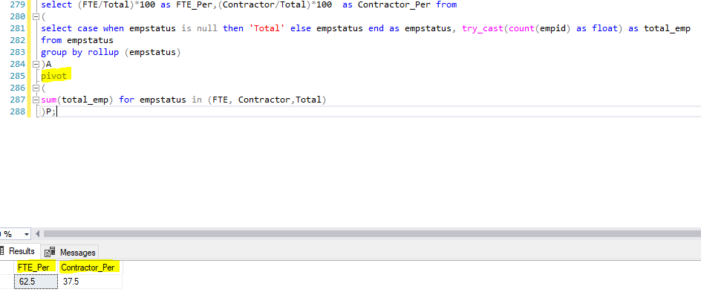**select (FTE/Total)*100 as FTE_Per,(Contractor/Total)*100  as Contractor_Per from  
   ( select case when empstatus is null then 'Total' else empstatus end as empstatus, try_cast(count(empid) as float) as total_emp  
   from empstatus  
   group by rollup (empstatus) )A  
   pivot (sum(total_emp) for empstatus in (FTE, Contractor,Total) )P;**
5. Find the Average of hours worked department wise
6. 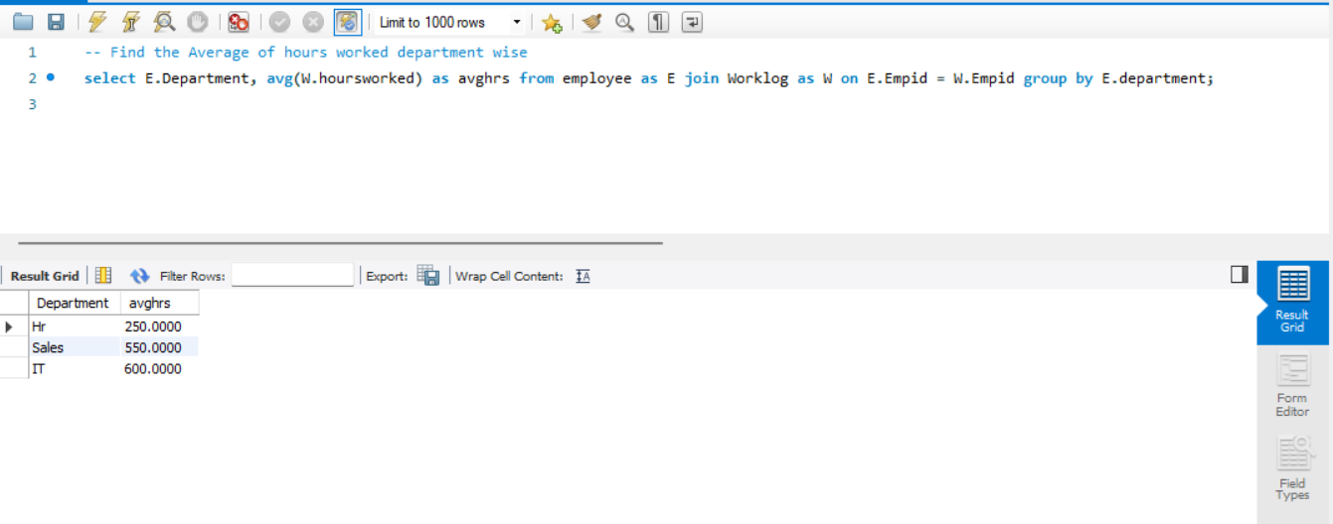**select E.Department, avg(W.hoursworked) as hrs from employee as E join Worklog as W on E.Empid = W.Empid group by E.department;**
7. **Output: Department, percentageofhours,PercentageofEmployees, TotalnumberofEmployees**
8. select E.Department, hoursworked*100/sum(hoursworked) as percentageofhours, count(empname)/6*100 as percentageofEmployees, Count(Empname) as Totalnumberofemployee from employee as E join Worklog as W on E.Empid = W.Empid group by department, hoursworked;

